**MY SQL TASK**

**1. Create a table employee to store employee details.**

create database Empl1;

create table Empl1(empno int, ename varchar(20), job varchar(20), mgr varchar(20), hiredate date, sal double ,comm varchar(20), deptno int);

describe Empl1;

insert into Empl1 values(8369,'SMITH','CLERK', 8902 ,'1990-12-18', 800.00,'NULL', 20);

insert into Empl1 values(8499,'ANYA','SALESMAN', 8698 ,'1991-02-20', 1600.00,300.00, 30);

insert into Empl1 values(8521,'SETH','SALESMAN', 8698 ,'1990-02-22', 1250.00,500.00, 30);

insert into Empl1 values(8566,'MAHADEVAN','MANAGER', 8839 ,'1991-04-02', 2685.00,'NULL', 20);

insert into Empl1 values(8654,'MOMIN','SALESMAN', 8698 ,'1991-09-28', 1250.00,1044.00, 30);

insert into Empl1 values(8698,'BINA','MANAGER', 8839 ,'1990-12-18', 2850.00,'NULL', 30);

insert into Empl1 values(8882,'SHIVANSH','MANAGER', 8839 ,'1991-06-09', 2450.00,'NULL', 10);

insert into Empl1 values(8888,'SCOTT','ANALYST', 8566 ,'1992-12-09', 3000.00,'NULL', 20);

insert into Empl1 values(8839,'AMIR','PRESIDENT', 'NULL' ,'1991-11-18', 5000.00,'NULL', 10);

insert into Empl1 values(8844,'KULDEEP','SALESMAN', 8698 ,'1990-09-08', 1500.00,0.00, 30);

select * from Empl1;

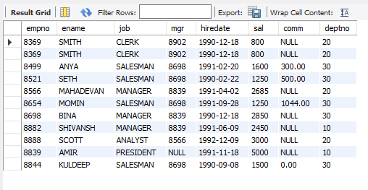

**2. To display EName and Sal of employees whose salary is greater than or equal to 2200:**

* SELECT ename, sal FROM Empl1 WHERE sal >= 2200;

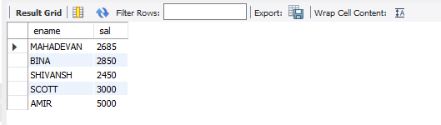

**3. To display details of employees who are not getting commission:**

* SELECT * FROM Empl1 WHERE comm IS NULL;

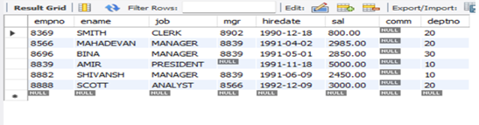

**4. To display employee name and salary of those employees who don’t have their salary in the range of 2500 to 4000:**

* SELECT ename, sal FROM Empl1 WHERE sal NOT BETWEEN 2500 AND 4000;

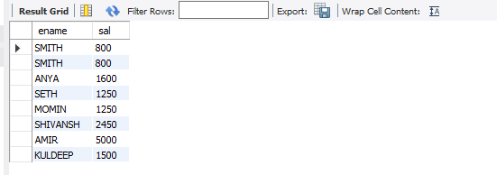

**5. To display the name, job title, and salary of employees who don’t have a manager:**

* SELECT ename, job, sal FROM Empl1 WHERE mgr IS NULL;

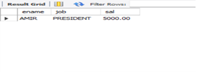

**6. To display the name of an employee whose name contains "A" as the third alphabet:**

* SELECT ename FROM Empl1 WHERE SUBSTRING(ename, 3, 1) = 'A';

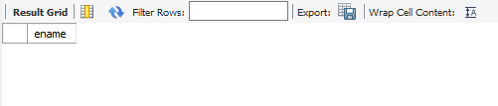

**7. To display the name of an employee whose name contains "T" as the last alphabet:**

* SELECT ename FROM employee WHERE RIGHT(ename, 1) = 'T';

